**Documentation for Isolated-word speech recognition using hidden Markov models.**

1. **We will first open the main.m File**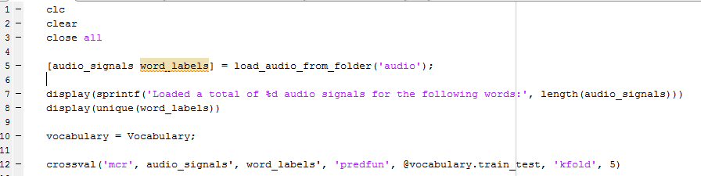

Which looks like this.

The first three lines of code are for clearing command window, clearing workspace and closing all unnecessary windows.

Then comes the below which is explained further below

**C:\Users\Vaaibhav\Documents\Projects\vedanti\speech recognition\scode\hmm-speech-recognition-0.1\hmm-speech-recognition\Documentation\1.PNG**

**The load audio from folder function takes ‘audio’(folder name as input ) and returns all the audio files and names of the files excluding there .extension**

**C:\Users\Vaaibhav\Documents\Projects\vedanti\speech recognition\scode\hmm-speech-recognition-0.1\hmm-speech-recognition\Documentation\2.PNG**

**The above line displays the total number of audio signals that have been loaded from the folder.**

**C:\Users\Vaaibhav\Documents\Projects\vedanti\speech recognition\scode\hmm-speech-recognition-0.1\hmm-speech-recognition\Documentation\3.PNG**

**This line displays the names of the files and removes redundancy and displays only the name once.**

**C:\Users\Vaaibhav\Documents\Projects\vedanti\speech recognition\scode\hmm-speech-recognition-0.1\hmm-speech-recognition\Documentation\4.PNG**

**This line is used to initiate the Vocabulary function.**

**Which will take It to vocabulary.m file. Which is explain below**